**Credit Card Application Data Analysis Report**

Business Problem

The business problem addressed in this project is to improve the credit card approval process for a financial institution. The current process lacks efficiency and accuracy, leading to potential financial risks and customer dissatisfaction. By leveraging exploratory data analysis (EDA) and advanced feature engineering techniques, the goal is to identify significant patterns and influential features that impact credit card approval decisions. The objective is to develop a more accurate credit scoring model that can assess creditworthiness reliably, enabling the institution to make informed and data-driven decisions. This will help streamline the approval process, minimize default risks, and enhance overall decision-making in credit card applications.

Research Questions

1. Group the customers based on their income type and find the average of their annual income.
2. Find the female owners of cars and property.
3. Find the male customers who are staying with their families.
4. Please list the top five people having the highest income.
5. How many married people are having bad credit?
6. What is the highest education level and what is the total count?
7. Between married males and females, who is having more bad credit?

Hypothesis

**Hypothesis:** The higher the annual income of a customer, the more likely they are to have a better credit worthiness score. Additionally, customers who are working professionals are more likely to have a better credit worthiness score compared to other employment types. Lastly, customers who own property are more likely to have a better credit worthiness score than those who do not own property.

**Null hypothesis:** There is no significant relationship between customers' annual income, employment type, property ownership, and their credit worthiness.

**Alternative hypothesis:** There is a significant relationship between customers' annual income, employment type, property ownership, and their credit worthiness.

Figure A majority of the credit card applicants (approximately 63%) in the dataset are females.

2.

Insights From the Data

A majority of the credit card applicants (approximately 63%) in the dataset are females.

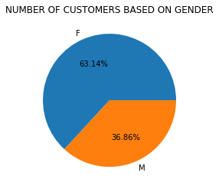

The dataset reveals that around 68% of the applicants are married, while the remaining applicants are single, widowed, or separated from their partners.

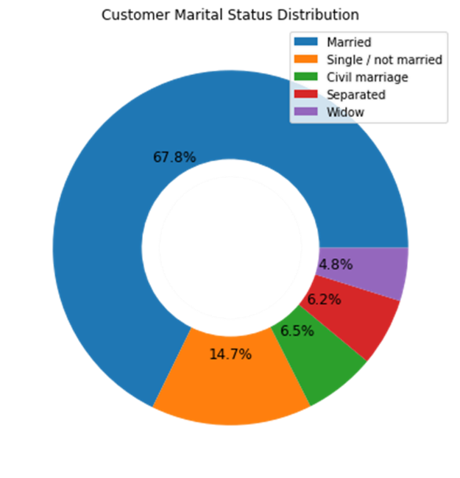

In terms of education level, approximately 67% of the applicants have completed secondary education, 27% have completed higher education, and only a few have completed graduation

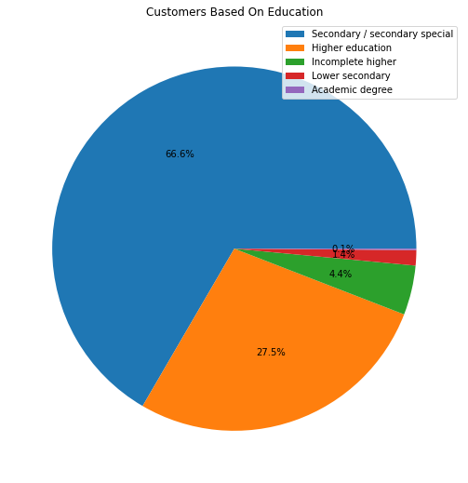

Distribution based on the type of occupation reveals that 25% are laborers, 16% are core staff, 13% are managers, 11% are sales staff, 8% are drivers, and 6% are highly skilled staff.

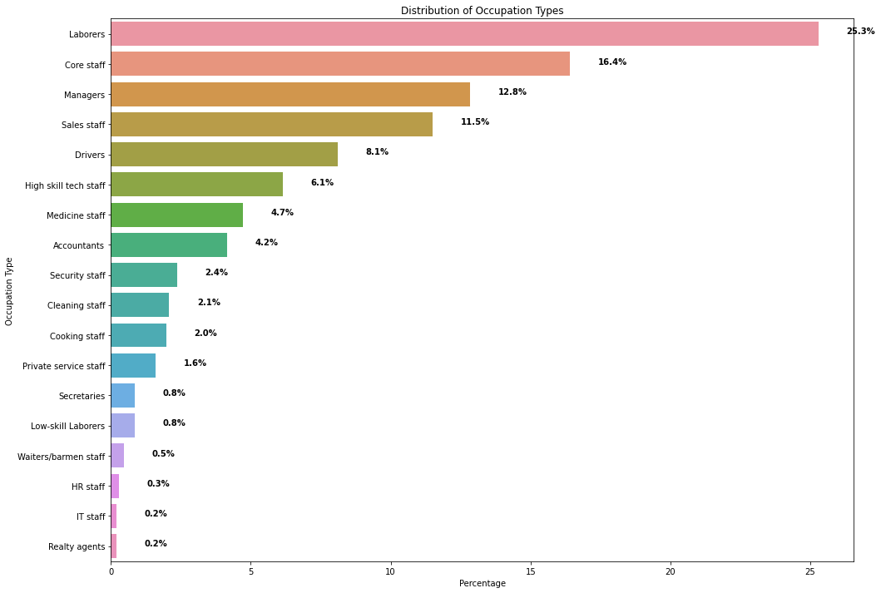

Analyzing the occupation types, it can be observed that 51.6% of the applicants are working professionals, 23.6% are commercial associates, 17.4% are pensioners, and 7.5% are state servants.

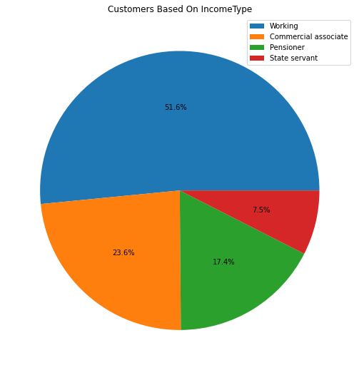

About 60% of the applicants own a car, while the remaining 40% do not.

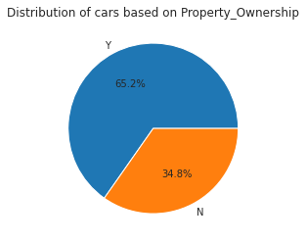

Among pensioners, commercial associates, working people, and state servants, a small percentage own a car, while the majority do not.

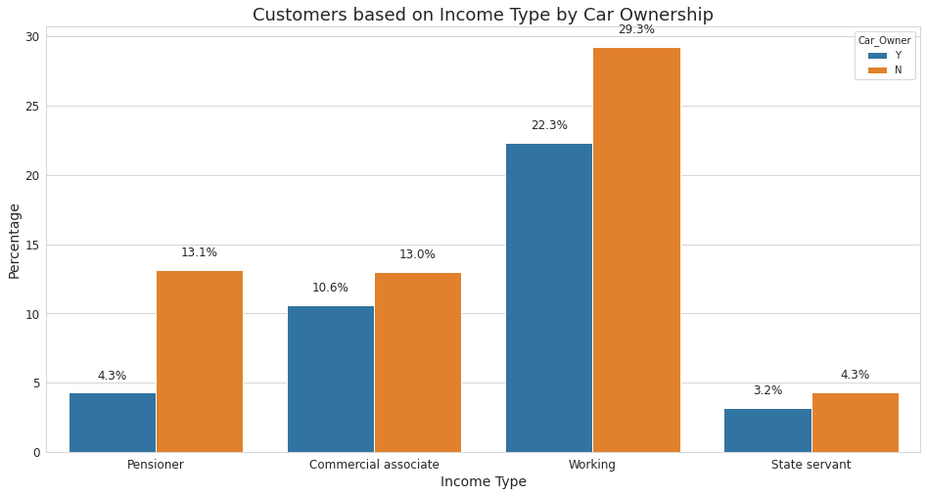

Among pensioners, commercial associates, working people, and state servants, a small percentage own a car, while the majority do not.



Approximately 65% of the applicants have their own property, while the remaining 35% do not have any ownership.

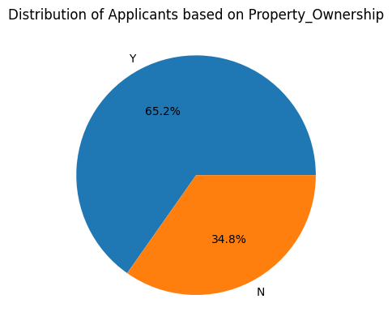

The majority of the applicants reside in houses or apartments, with only a few living with their parents or in rented, municipal, office, or co-op apartments.

